

Frequently Asked Questions
About the
APEC Meeting Document Database

This document is available in the APEC Meeting Document Database. To access it, click on Help in the navigation bar at the top of the screen.
Last updated: July 2017
TABLE OF CONTENTS

PASSWORDS ……………………………………………………………………………………….. | 3
For whom? ................................................................................................................. | 3
How to obtain a password ………………………………………………………………… | 3
GETTING STARTED ……………………………………………………………………………….. | 4
DOCUMENT ARCHIVE …………………………………………………………………………….. | 5
Extent of Archive ……………………………………………………………………………….. | 5
Electronic archive ………………………………………………………………………….. | 5
Paper archive ……………………………………………………………………………… | 5
Document Posting ……………………………………………………………………………… | 5
Document Formats ……………………………………………………………………………... | 5
DOCUMENT NOMENCLATURE ………………………………………………………………….. | 6
Document Types ……………………………………………………………………………….. | 6
What is a document type? ………………………………………………………………... | 6
Document Number ……………………………………………………………………………... | 6
What is a document number? ……………………………………………………………. | 6
BROWSE DOCUMENTS …………………………………………………………………………... | 7
Introduction | 7
What can you find in Browse? | 7
Browse – APEC Group | 7
Browse – Frequently Consulted – Leaders’ Declarations | 8
Browse – Frequently Consulted – Ministerial Statements | 8
Browse – Frequently Consulted – Summary Records | 9
Browse – Meetings | 9
SEACRHING FOR DOCUMENTS ………………………………………………………………… | 11
Introduction ……………………………………………………………………………………… | 11
Simple search mode ………………………………………………………………………. | 11
Advanced search mode …………………………………………………………………… | 11
Online help …………………………………………………………………………………. | 11
Field Searching …………………………………………………………………………………. | 12
Search by APEC group …………………………………………………………………… | 12
Search by date range ……………………………………………………………………... | 12
Search by document title …………………………………………………………………. | 12
Search by full text ………………………………………………………………………….. | 13
Search by document type ………………………………………………………………… | 14
Search by submitted by economy ……………………………………………………….. | 14
Search by submitted by APEC entity ……………………………………………………. | 14
Search by submitted by organisation / entity …………………………………………… | 14
Search by meeting name …………………………………………………………………. | 14
Search by meeting venue – economy …………………………………………………… | 15
Search by meeting venue – city ………………………………………………………….. | 15
Search by document number …………………………………………………………….. | 15
CONSULTING DOCUMENTS …………………………………………………………………….. | 16
Understanding the Results List ……………………………………………………………….. | 16
Sorting the Results List ………………………………………………………………………… | 16
Catalogue Records …………………………………………………………………………….. | 17
Printing …………………………………………………………………………………………... | 18
CONTACTS ………………………………………………………………………………………….. | 19

Disclaimer: All images appear in this user guide serves as sample image and may not reflect the real environment because of changes or enhancements.
PASSWORDS

For whom?

A small number of official documents are issued with a restricted status; access to these items is reserved for APEC Officials and Official APEC Observers. Restricted documents are posted in the APEC Meeting Document Database but a login user ID and password are required to access these documents.

APEC Officials who have been issued with a user ID and password to access to the APEC Information Management Portal (AIMP) can access the APEC Meeting Document Database with the same user ID and password.

APEC Officials who are not members of the APEC Information Management Portal (AIMP) but require access to the full APEC Meeting Document Database including restricted documents, can contact the relevant APEC Economy Contact Point for assistance to obtain the APEC Economy user ID and password.

How to obtain a password

An APEC Economy user ID and password is issued to each APEC Economy Contact Point; to obtain these, please contact the appropriate APEC Economy Contact Point directly.

For contact details, see: Contacts

GETTING STARTED

The APEC Meeting Document Database provides two distinct services:

- document dissemination

- document search and retrieval.

The first offers APEC Officials, APEC Official Observers and the public the means to access APEC meeting documents after meetings are completed. The second service offers users the means of performing both simple and more complex document searches.

The APEC Meeting Document Database is accessible via the APEC website http://mddb.apec.org

DOCUMENT ARCHIVE

Extent of Archive

Electronic archive

The APEC Meeting Document Database provides access to APEC meeting documents. The database currently contains APEC meeting documents from 2004 onwards and selected material from 1989 to 2003, principally leaders’ declarations, ministerial statements, and summary records of meetings.

The APEC Meeting Document Database does not contain APEC publications; these are available from the Publications section of the APEC website at: http://publications.apec.org/

Paper archive

A comprehensive printed archive of APEC documents is available for consultation in the APEC Secretariat library, which is located at the APEC Secretariat in Singapore.

Document Posting

Documents are posted on the database after they are received and checked at the APEC Secretariat after meetings.

Document Formats

Documents are largely posted as Portable Document Format files (.pdf).

To view or download these files you need Adobe® Acrobat® Reader®. This can be downloaded free from the Adobe site: http://www.adobe.com/

DOCUMENT NOMENCLATURE

Document Types

What is a document type?

These documents share certain attributes, for example, a common structure or a specific type of data content. On the APEC Meeting Document Database, the documents are classified according to the following document types:

- Agenda
- Document List
- Leaders’ Declaration
- Ministerial Statement – Annual
- Ministerial Statement – Sectoral
- Participant List
- Paper
- Summary Record

Document Number

What is a document number?

It is an identifier of an APEC meeting document. The document number is the counterpart of the call number or shelf number that used in libraries to identify materials.

Examples of APEC document numbers

2006/SOM3/024
2005/AMM/002rev1
2005/ATCWG/001

Each number comprises a combination of letters and numbers. Each document number starts with the year in YYYY format. Additionally, letters are used to identify APEC groupings while numbers are used to indicate sequential order. Common suffixes used in document numbers include “rev” for revision; “add” for addendum; “att” for attachment; “anx” for annex; and “cor” for corrigendum.

BROWSE DOCUMENTS

Introduction

What can you find in Browse?

A selection of pre-programmed queries of the APEC Meeting Document Database permitting the easy retrieval of core and frequently requested documents. No knowledge of the database or of search techniques is required of the user - just click on the different links to display the corresponding documentation. Relevant new documents are automatically retrieved by these queries as soon as they are posted in the APEC Meeting Document Database.

Under Browse, users can view documents by APEC Group; by Frequently Consulted documents that provide quick access to leaders’ declarations, ministerial statements, and summary records of meetings; and by Meetings.

Browse – APEC Group

How does it work?

- Go to Browse > click on APEC Group

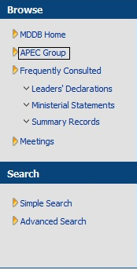

- Users will be redirected to browsing interface of APEC groupings:

- Click on Grouping to view the APEC groups by structure. Click on the Alphabetical view to view the APEC groups in an ascending (A-Z) alphabetical order.

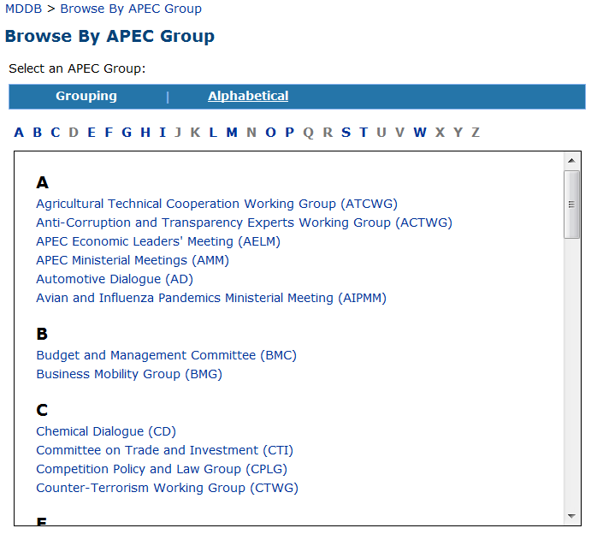

- Once the intended APEC group is selected, select the relevant year(s) of the documents. Multiple years can be selected by holding the CTRL key.

- Then click on the Browse button. The relevant results will be returned.

- By default, the search result will be sorted by Year (meeting start date) in reverse chronological. Further sorting is allowed in the result page by clicking on sorting icons on the column header.

Browse – Frequently Consulted – Leaders’ Declarations

How does it work?

- Go to Browse > Frequently Consulted and then click on Leaders’ Declarations

- Users will be redirected to the Leaders’ Declarations page where relevant documents will be displayed.

- By default, the search result will be sorted by Year (meeting start date) in reverse chronological. Further sorting is allowed in the results page by clicking on sorting icons on the column header.

Browse – Ministerial Statements

How does it work?

- Go to Browse > Frequently Consulted and then click on Ministerial Statements

- Users will be redirected to the Ministerial Statements page, which consists of:

  - Annual Ministerial Statements (single link)
  - Sectoral Ministerial Statements (multiple sub links)

- To view Annual Ministerial Statements, click on Annual Ministerial Statements. A page containing relevant documents will be displayed.

- By default, the search result will be sorted by Year (meeting start date) in reverse chronological. Further sorting is allowed in the result page by clicking on sorting icons on the column header.

- To view Sectoral Ministerial Statements, return to the Ministerial Statements page.

- Click on any of Sectoral Ministerial Statements’ sub links. Note: not all sectoral ministerial meetings are held annually.

- Users will be redirected to the page containing relevant documents. By default, the search result will be sorted by Year (meeting start date) in reverse chronological. Further sorting is allowed in the result page by clicking on sorting icons on the column header.

Browse – Frequently Consulted – Summary Records

How does it work?

- Go to Browse > Frequently Consulted and then click on Summary Records

- Users will be redirected to the browsing interface of Summary Records.

- In the Select an APEC Group option, click on Grouping to view the APEC groups by structure. Click on the Alphabetical to view the APEC groups in an ascending (A-Z) alphabetical order.

- Once the intended APEC group is selected, select the relevant year(s) of the documents. Multiple years can be selected by holding the CTRL key.

- Click on the Browse button. The relevant results will be returned.

- By default, the search result will be sorted by Year (meeting start date) in reverse chronological. Further sorting is allowed in the result page by clicking on sorting icons on the column header.

Browse - Meetings

How does it work?

- Go to Browse > Click on Meetings

- Users will be redirected to a page with the following interface:

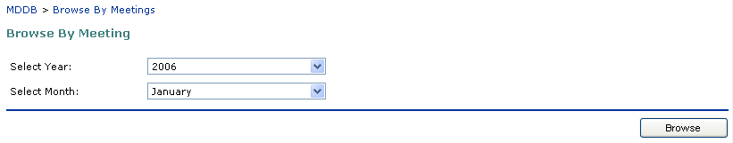
- Year (Displayed in reverse chorological order, starts with 1989)

- Month (Displayed in ascending order)

- Select the relevant Year and Month to narrow down the search scope.

- Click on the Browse button. The documents relevant to the search scope will be displayed in the results page.

- There will be two functions available to the user that is the Browse and Download options.

- Clicking on the Browse icon will allow users to view all documents related to the meeting for meetings that have a complete set of documents available electronically. Note: For meetings where not all documents are available electronically, only the subset of electronically available documents will be displayed.

- Clicking on Download icon will allow users to choose to download the file(s).

- Click on the link(s) to download the files.

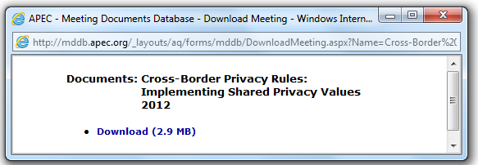
SEARCHING FOR DOCUMENTS

Introduction

The APEC Meeting Document Database offers two types of search technique: full text searching and database (catalogue) searching.

Full text searching permits the identification of a single word or words or phrase within the text of a document; database searching enables the identification of documents on the basis of specified criteria such as title, APEC group, document type, meeting dates, etc. When applied in tandem, these techniques enable the user to perform very precise searches, which filter out documents that do not correspond to the search criteria.

Two search modes are available: simple and advanced.

Click on Search in the left-hand side of the screen. The simple mode is the default mode. Click on Advanced Search or More fields to change to the more detailed search screen.

Simple search mode

In this mode, the search is constructed by entering criteria in one or more of several key data fields where (C) = catalogue data field:

APEC Group (C)
Date Range (C)
Document Title (C)
Full Text Search

Advanced search mode

In this mode, the search is constructed by entering criteria in one or more of the full range of catalogue data fields. The following data fields are available:

APEC Group (C)
Date Range (C)
Document Title (C)
Document Type (C)
Full Text Search
Submitted by Economy (C)
Submitted by APEC Entity (C)
Submitted by Organisation/Entity (C)
Meeting Name (C)
Meeting Venue - Economy (C)
Meeting Venue - City (C)
Document Number (C)

Online help

A considerable effort has been made to ensure that APEC Meeting Document Database is as user-friendly as possible. Specific help files are available on-screen behindto assist users in the using the database. They can be used, for example, to identify economy names, names of APEC entities, names of organisations, document types, etc.

In the Browse section, users can quickly retrieve and view the "most frequently consulted documents" in the database simply by clicking on hyperlinks. This kind of searching requires no prior knowledge of the structure of APEC documentation or of the current nomenclature.

Field Searching

Search by APEC group

Purpose of field: to limit the search for documents by APEC group

You can type the APEC group name directly in the field if you wish; an online help file is also available. To activate, click on to the right of the APEC group field in the search interface. The help file is organised in two ways: by structure and in an ascending (A-Z) alphabetical order. If you click on a group name, it will be added to the search form. You can make multiple selections; it will automatically combine your criteria in an “or” statement.

Search by date range

Purpose of field: to limit the search for documents by the meeting date

You can type the date directly in the start and end fields, respecting the prescribed format: YYYY/MM/DD
You can also use the online calendars to select dates. To activate, click on to the right of the start date and end date fields in the search interface.

Search tips
- If you unsure of the exact meeting dates, just select a range such as the first of the month to last day of the month.

- A quick way to search for all documents in a specific year is to enter the year element of the document number in the document number field, followed by an asterisk (*): 2006* will retrieve all documents for the year 2006.

Search by document title

Purpose of field: to limit the search for documents by a word or words in the document title

You can search by full title, by phrases from the title or by entering individual keywords from the title separated by boolean operators.

Examples

full title: APEC strategy to address IAS threats to trade and economic development

phrase from the title: “IAS threats”

keywords separated by boolean operators: strategy and IAS and development

Using the boolean "and" feature means that both elements of the search have to be found in the title for it to be retrieved. Booleans are not case sensitive and do not need to be italised as in the example above.

and Finds documents containing all of the specified words or phrases: strategy and IAS finds documents with both the word strategy and the word strategy.

or Finds documents containing at least one of the specified words or phrases: strategy or IAS finds documents containing either strategy or IAS. The found documents could contain both items, but not necessarily.

not Excludes documents containing the specified word or phrase: strategy not IAS finds documents with strategy but not containing IAS.

* The asterisk is a wildcard; any letter can take the place of the asterisk. “Import*“ would find import, imports, importation, importation, imported, importing, etc. When using the asterisk, the word needs to be enclosed in double quotes e.g. “secur*”.

( ) Use parentheses to group complex boolean phrases. For example, (strategy and IAS) and (Mexico or Japan) finds documents with the words strategy and IAS, and Mexico or Japan, or both.

phrase Remember to enclose the text in double quotes ("…") if you want to search for a specific string of characters, otherwise the search will be performed on each individual word entered in the field.

near The near term is used to specify that two search terms are relatively close to one another in approximately 50 words apart. No result returns when the search terms are located further apart. Example of search: computer software near hardware.

Search tip
APEC document titles may not always clearly reflect the subject content. Search preferably on a word or words appearing in the title combined with the boolean operator "and" rather than on full titles (one error in a word in the title will return a zero result!). Performing a search using data fields other than the title field will probably yield a more pertinent result.

Search by full text

Purpose of field: to limit the search for documents by a word or words in the body of the text of the document

Type the text that you are looking for within the documents posted in APEC Meeting Document Database. Then click on Search. Remember to enclose the text in double quotes ("…") if you want to search for a specific string of characters, otherwise the search will be performed on each individual word entered in the full text field.

Simple searches

- At its simplest, a search query can be just a word; with the tips on this page, you can refine your search to give you more complete results.

- Look for a phrase by typing the whole phrase. For example, type "developments in trade facilitation" to find the exact phrase developments in trade facilitation. The search is not case-sensitive. Without the double quotes, this query would search for occurrences of all words anywhere in the document instead of where they appear adjacent to each other.

Complex searches

Boolean

- Look for two or more words at once by using the and operator. Example - type measures and conservation to find documents that have both the word measures and the word conservation anywhere.

- Use and, or, not and near literally by employing double quotes ("..."). Example - type "public and business" to retrieve and as a word and not as a boolean operator. Without the double quotes, this query would search for occurrences of all words anywhere in the document instead of the specific phrase.

- Limit your search by using the not operator to exclude words. Example - type safeguards and not questions posed to find all instances of safeguards, as long as the phrase questions posed does not appear in the document.

- Use the or operator to look for several unconnected words in a document. Note: If you don't use the or operator and search using multiple words, the words are treated as a phrase. Example - type sea or maritime to find the word sea or the word maritime, but not necessarily both.

- Look for words that begin with the same letters by using a single asterisk (*). Example - type “import*“ to find import, imports, importation, importation, imported, and so on.

Search by document type

Purpose of field: to limit the search for documents by type of document.

You can enter the type of document search criteria directly in the type field if you wish; an online help file is also available. To activate, click on to the right of the Document Type field in the search interface. The help file is organised alphabetically; if you click on a type, it will be added to the search form. You can make multiple selections; it will automatically combine your criteria in an or statement.

Search by submitted by economy

Purpose of field: to limit the search for documents submitted by an economy

You can type the economy name directly in the field if you wish; an online help file is also available. To activate, click on to the right of the economies field in the search interface. The help file is organised alphabetically; if you click on an economy name, it will be added to the search form. You can make multiple selections; it will automatically combine your criteria in an or statement.

Search by submitted by APEC entity

Purpose of field: to limit the search for documents submitted by an APEC entity

You can type the names directly in the field if you wish; an online help file is also available. To activate, click on to the right of the field in the search interface. The help file is organised alphabetically; if you click on the name, it will be added to the search form. You can make multiple selections; it will automatically combine your criteria in an or statement.

Search by submitted by organisation / entity

Purpose of field: to limit the search for documents submitted by organisation / entity

You can type the organisation/entity name directly in the field if you wish; an online help file is also available. To activate, click on to the right of the field in the search interface. The help file is organised alphabetically; if you click on the name of an item, it will be added to the search form. You can make multiple selections; it will automatically combine your criteria in an or statement.

Search by meeting name

Purpose of field: to limit the search for documents by a word or words in the meeting name

You can search by full meeting name, by phrases from the title or by entering individual keywords from the title separated by boolean operators.

Examples

meeting name: Seminar on product related environmental regulations in the EU

phrases from the meeting name: “environmental regulations”

keywords separated by boolean operators: product and environmental and EU

Search tip
Search preferably on a word or words appearing in the title combined with the boolean operator "and" rather than on full titles (one error in a word in the title will return a zero result!).

Search by meeting venue – economy

Purpose of field: to limit the search for documents of meetings held in a particular economy

You can type the economy name directly in the field if you wish; an online help file is also available. To activate, click on to the right of the economies field in the search interface. The help file is organised alphabetically; if you click on an economy name, it will be added to the search form. You can make multiple selections; it will automatically combine your criteria in an or statement.

Search by meeting venue – city

Purpose of field: to limit the search for documents of meetings held in a particular city

You can type the city name directly in the field if you wish; an online help file is also available. To activate, click on to the right of the economies field in the search interface. The help file is organised alphabetically; if you click on a city, it will be added to the search form. You can make multiple selections; it will automatically combine your criteria in an or statement.

Search by document number

Purpose of field: to limit the search for documents by document number

If you are familiar with the APEC document nomenclature, you can type the document number including the appropriate code directly in the field. A document number can be retrieved by searching on its full form or by its constituent parts. The wildcard * may also be used.

Example

To retrieve all documents in ATCWG document for 2005

Type: 2005/ATCWG/*

Do not type: ATCWG* (the first part of the symbol is required in the search query)

Note: As the code sequence for some of the APEC groups has varied over the years, it is advisable not to use this field unless you know the exact number or are familiar with the document codes for the specific meeting.

CONSULTING DOCUMENTS

Understanding the Results List

The results of a search of APEC Meeting Document Database are always presented in a standard display, whether the query was performed using the Browse or the Search interfaces.

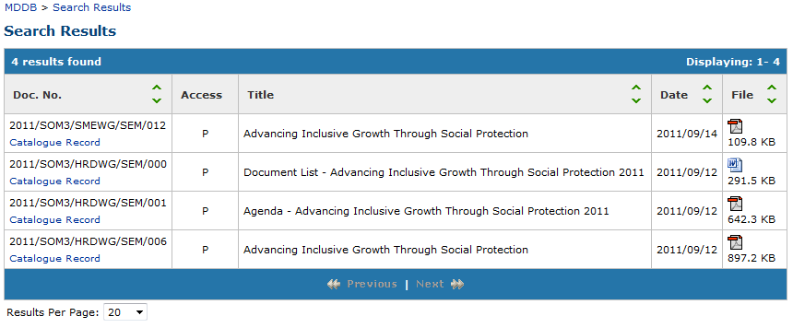

By default, the results appear in reverse chronological order. You can also select to have the search results displayed in order of relevance on the Basic or Advanced Search screen interface (please see below).

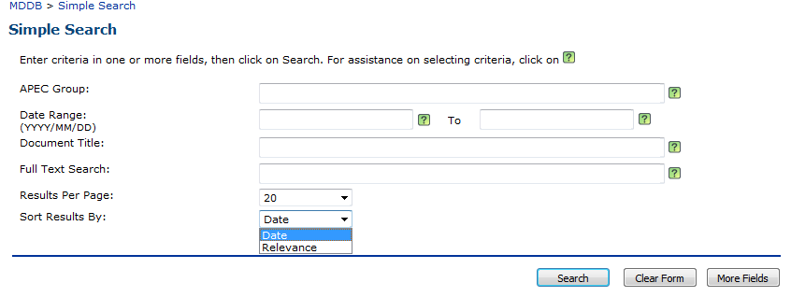

The maximum number of documents that may be retrieved by a search is 600. If there are more that 600 hits, the first 600 are displayed together with this message: Your search returned more than 600 documents. Please refine your search.

The results list provides the following information for each document retrieved:

Doc. No.: meeting document number
Access: document classification
R = restricted
P = public
Title: title of the meeting document
Date: meeting start date
File: file format; the size in bytes (KB) of the document

The number of matches found by the search appears at the top left corner of the list; users can select the number of results to be displayed per page, which consists of 10, 20, 50 or 100 results. The default option will be 20 results; the [previous] and [next] buttons at the bottom of the results display allow the user to navigate through the previous and subsequent pages of the full list of results.

To modify the number of documents displayed per page, click on the drop-down list at the bottom right of the results display and choose a number.

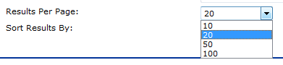
Sorting the Results List

The results list may be sorted in ascending or descending order by clicking on the arrows in the label at the head of the following display columns: Doc. No., Title, Date, File

Catalogue Records

APEC Meeting Document Database makes available a descriptive catalogue record for every document stored in the database. To view a record, click on Catalogue record in the results display.

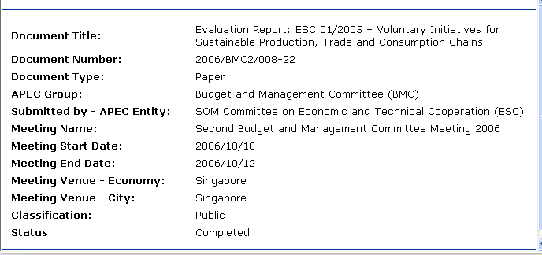

Printing

As a rule of thumb, it is best to first download a document to your computer and then open it to print. This is especially true for documents of more than a few pages in size. Printing large documents directly over the network can be very time consuming.

To print data displayed on any screen of APEC Meeting Document Database, use the standard print features of the Internet browser (Ctrl P).

Contacts

Contact for the APEC Meeting Document Database

Email: info@apec.org

